Controlling Module

Controlling is A finance Module for internal reporting and Balance Sheet.

FI is External Reporting

Sub Modules of Controlling

Cost Accounting (Operating Accounting)

Overhead Accounting

**Creating Profit Center**

App Name: Manage Profit Center

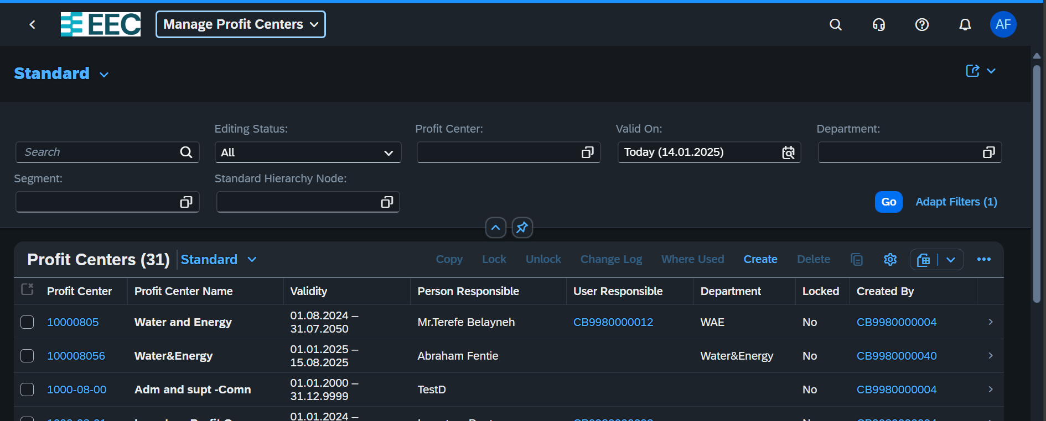

Click Create Button

Or we can create by Copy from Listed and Change the Value

Then fill the profit Center until 20 Digit then click Create Button upon accomplishing necessary fields

Sample

Our Profit Centers are

**Creating Cost Center**

**App Name: Manage *Cost Center***

Same Procedure with Profit Center

**Managing Cost Center Groups**

**Clixk New** then fill information

Crate Cost Element Group

**Create Activity**

**APP Name: Manage Activity type**

**Click Create Button**

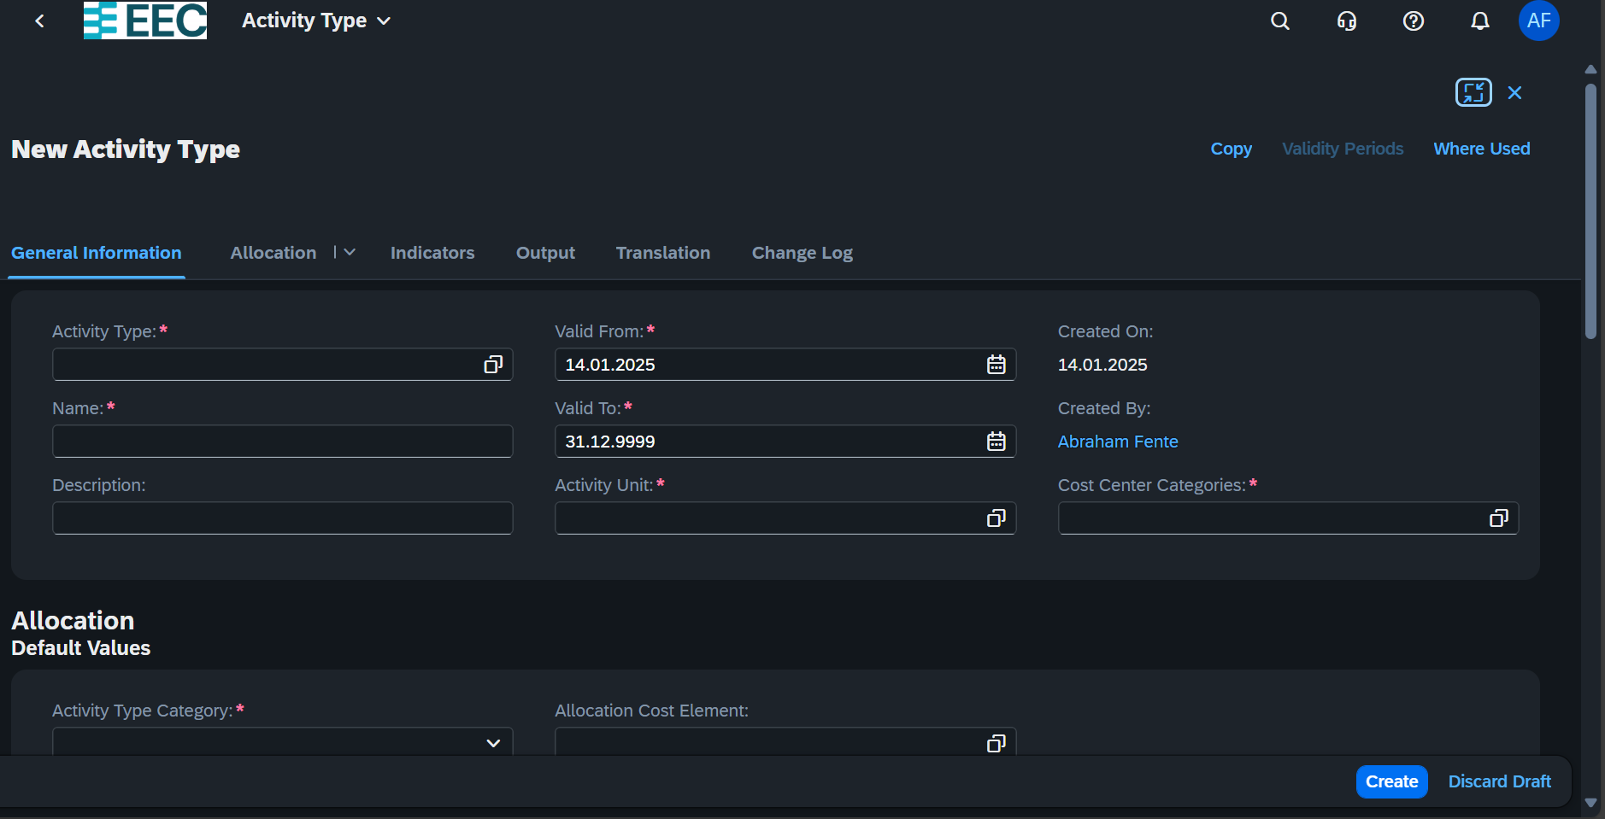

**Plan and Budget**

The break down for budge in cost center depends on the GL

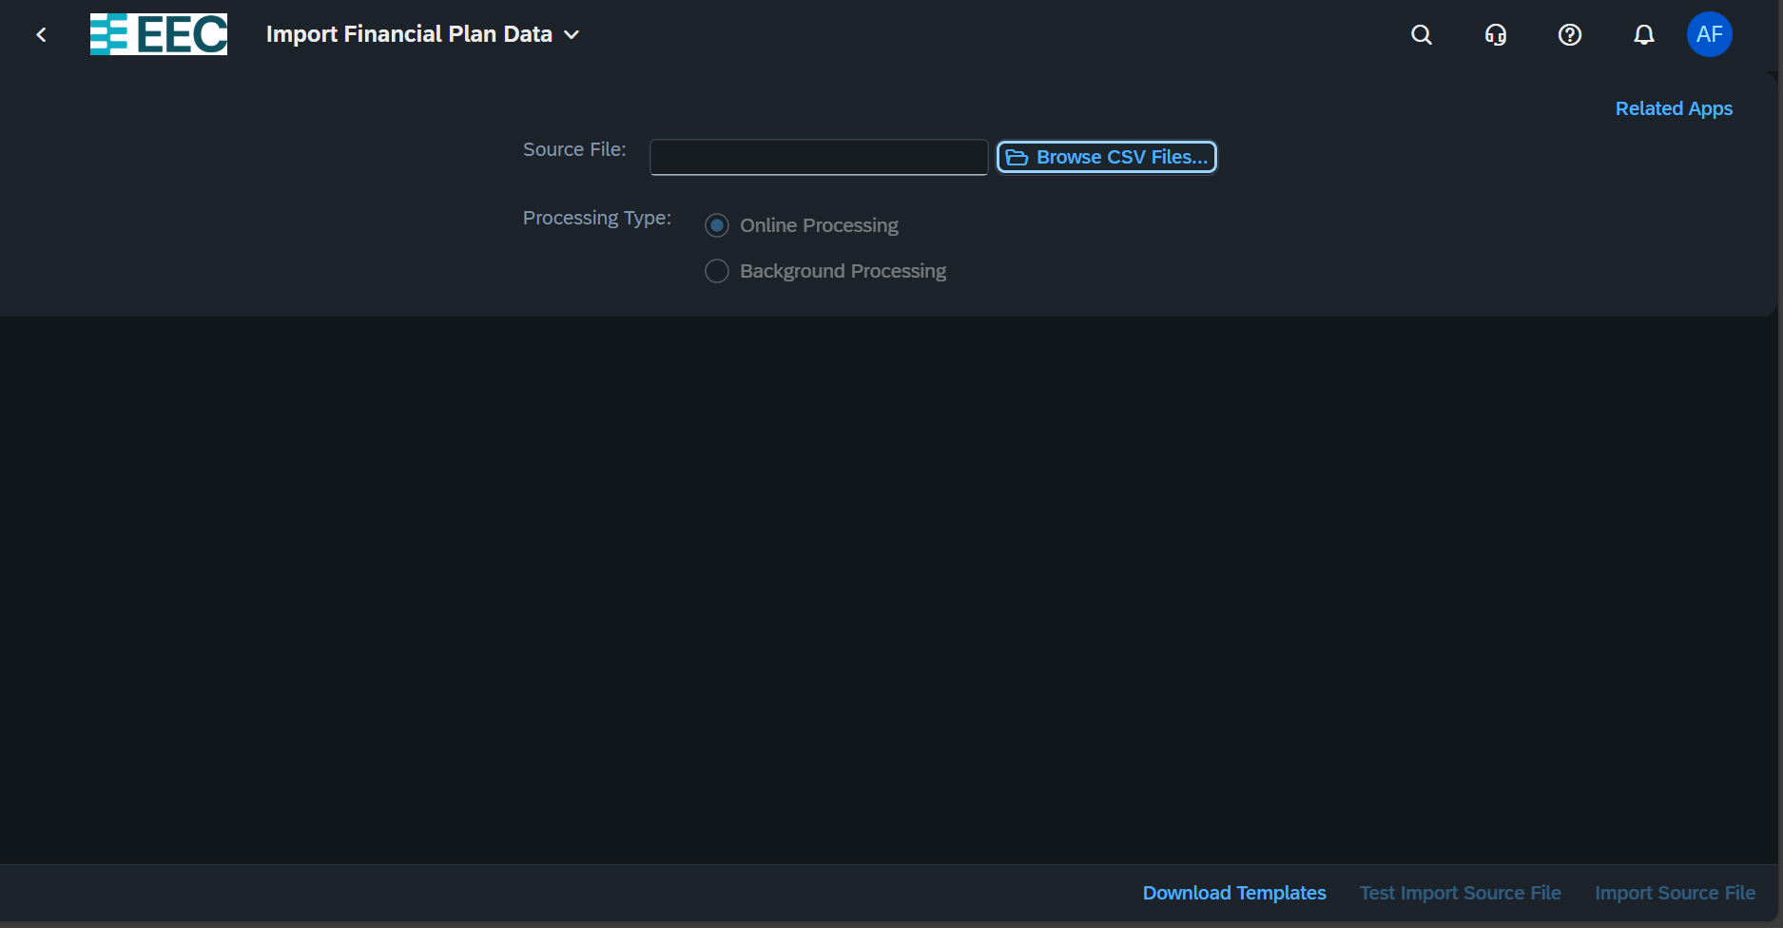

**Manage Cost Center Budget**

This helps to

* Transfer Budget: from one cost center to another cost center
* Budget Return: remove from that cost center without transferring to other cost center
* Budget Supplement: if extra budget is need.

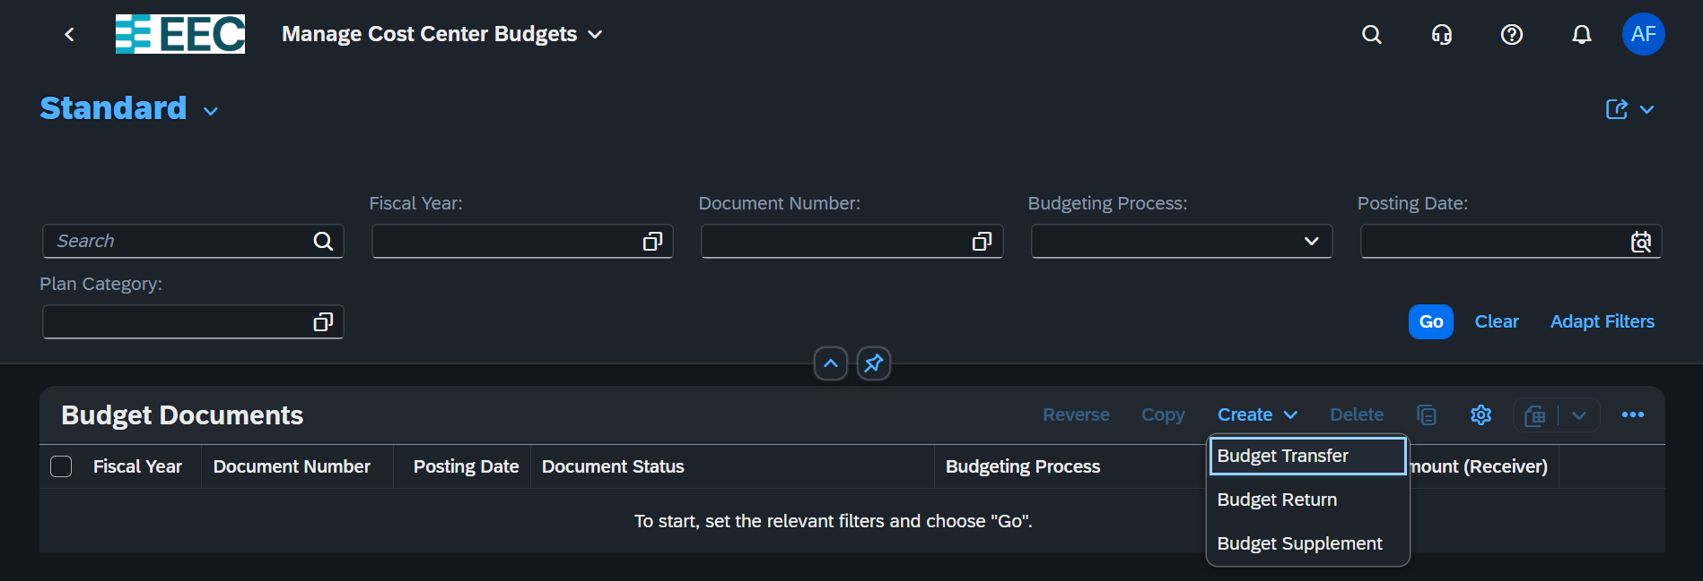

Then select the budget from uploaded one from plan budget.

**Mange Cost rate Plan**

This helps to control variation in Specific year

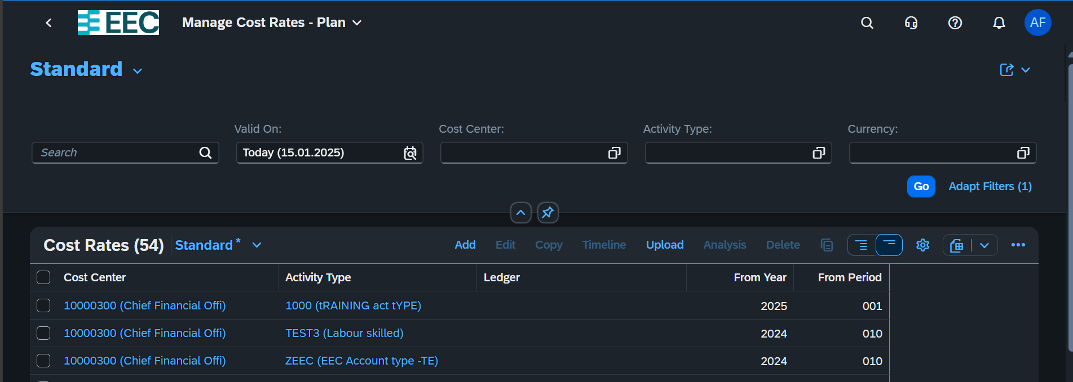

Click ADD button to create new rate

